COMPLETE ROS2 MAP SWITCHING PROCESS

In ROS2, map switching is not built-in — we must override the /map topic by publishing a new nav_msgs/OccupancyGrid message containing the new tile map.
Every Nav2 component subscribed to /map will automatically receive the new map (if QoS is set correctly).
Tile switching works because:
- we publish a new map on /map → AMCL + global_costmap immediately use it.
- Then you publish a new /initialpose → AMCL resets to correct pose based on ArUco marker.

STEP1:NODES RUNNING
- The system consists of these major nodes:
Node | Role
Nav2 Map Server (optional) | Usually publishes static map, but in switching method YOU replace it
Nav2 AMCL | Localizes robot using /map and laser scan
Nav2 Controller / Planner / BT Navigator | Performs global path planning and movement
Your Tile Switcher Node | Detects ArUco + publishes new tile map + resets AMCL
Camera Node | Publishes /camera/image_raw
TF2 | Provides transforms (base_link, camera_link)
LIDAR Node | Publishes /scan
Costmap Server(s) | Build global & local costmaps from /map

STEP 2:TOPIC SUBSCRIPTION AND PUBLICATION

Topic Subscriptions and Publications (Critical Part)
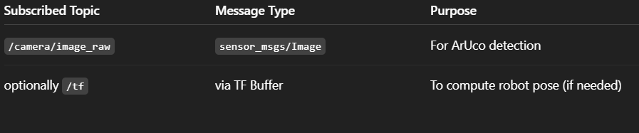
Tile Switcher Node subscriptions

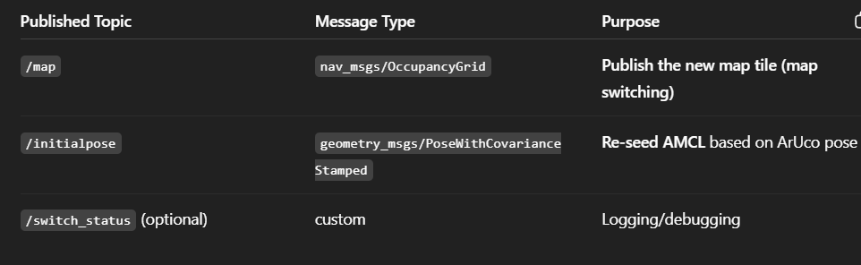
Tile Switcher Node publications:

STEP 3:
What ROS2 modules do with /map
AMCL subscribes to /map
- The moment you publish a new map on /map, AMCL receives it.
- AMCL internally resets and reconstructs likelihood fields based on the tile.
BUT AMCL still doesn’t know where the robot is.
That's why you must publish /initialpose.

Nav2 Costmap Server subscribes to /map
- Global costmap rebuilt using the tile
- Local costmap anchored to new map frame
- No code changes needed → costmap automatically updates

Nav2 Planner Server uses /map indirectly through costmaps
When map changes:
- Planner server will receive a new global costmap
- It can replan the global path automatically

STEP 4: SWITCHING SEQUENCE

STEP 1 — ArUco detected
Camera publishes → Tile switcher node receives image_raw
Tile Switcher:
- Detect marker corners (OpenCV aruco)
- SolvePnP → get marker pose in camera frame
- Apply TF camera→base_link → compute robot pose in map frame
- Identify which map tile to load next based on marker ID

STEP 2 — Tile Switcher publishes NEW MAP

STEP 3 — ROS2 Nav2 modules react
AMCL receives NEW /map
- AMCL clears old likelihood fields
- Recomputes map model
- Laser scan matching resets
Global Costmap Server receives new /map**
- Old obstacles cleared
- New costmap built from tile
- Boundaries, walls, corridors updated

Planner Server sees new /map via costmap**
- Global planner becomes aware of new environment
- It will need a new goal or forced replan

STEP 4 — Tile Switcher publishes /initial pose
- position (x, y, yaw) = pose computed from ArUco
- covariance tuned for safe AMCL initialization
AMCL sets the new robot pose in the new tile

STEP 5 — Nav2 Behavior Tree restarts navigation
- BT Navigator reads updated pose (from AMCL)
- Global planner replans path in new tile
- Controller follows new local plan

ROS2 Tile Switching Process (Full Flow) summary:
- Camera Node publishes /camera/image_raw.
- Tile Switcher Node detects an ArUco marker at a tile boundary.
- Tile Switcher computes robot pose from the detected marker using solvePnP and camera→base TF.
- Tile Switcher publishes the new tile map to /map with TRANSIENT_LOCAL QoS.
- AMCL, Global Costmap Server, and Planner Server immediately update because they subscribe to /map.
- Tile Switcher publishes /initialpose containing pose computed from ArUco.
- AMCL resets particle filter using /initialpose and aligns robot to the new tile.
- Tile Switcher calls Nav2 costmap clear services to remove old tile costmaps.
- Nav2 Behavior Tree (BT Navigator) triggers global replanning using the new map tile.
- Robot continues navigation inside the new map region.

